Multiple-choice section

|  |  |  |  |  |  |  |  |  |  |  |
| --- | --- | --- | --- | --- | --- | --- | --- | --- | --- | --- |
| Question | 1 | 2 | 3 | 4 | 5 | 6 | 7 | 8 | 9 | 10 |
| Answer | C | B | D | D | C | B | D | A | B | D |

Question 1 [3.1]

C

12 ÷ 4 = 3

 is 3 donuts

is 3 × 3 = 9 donuts

Question 2 [3.1]

B

 = 35 ÷ 7 = 5

Question 3 [3.1]

D

Two squares = , two triangles =

Total area shaded =

Question 4 [3.2]

D

HCF of 48 And 64 is 16



Question 5 [3.3]

C

The smallest ‘gap’ between one of the listed fractions and is .

Question 6 [3.4]

B

 =  =

Question 7 [3.4]

D

Both  and  are very close to 1, so their sum will be close to 2.

Question 8 [3.5]

A

 of $63



Question 9 [3.6]

B

 ÷ 



Question 10 [3.7]

D



Multiple-choice total marks: 10

Short answer section

Question 11 2 marks [3.1]

(a) Before you *add* fractions, you need to find the lowest common denominator.

(b) *Unit fractions* have a numerator equal to 1.

Question 12 2 marks [3.2]

 ( × ) ,  (× )... Multiply numerator and denominator by the same whole number.

Question 13 1 mark [3.1]



Question 14 3 marks [3.2]

(a)  (b)  (c) 

Question 15 6 marks [3.3]

|  |  |  |
| --- | --- | --- |
| (a)   so  is greater | (b)   is less than 1 whole. is less than 1 whole.  <   is closer to 1 than  < | (c)  > |

Question 16 6 marks [3.4]

|  |  |  |
| --- | --- | --- |
| (a)  –  LCD = 12 = −  =  = | (b) +  LCD = 24 = +  =  = | (c)  LCD = 40 = 4 − 2 +  = 2 +  = 1 +  = |

Question 17 6 marks [3.5]

|  |  |  |
| --- | --- | --- |
| (a)  of $35    = $28 | (b) | (c) |

Question 18 6 marks [3.6]

|  |  |  |
| --- | --- | --- |
| (a)  =  =  = 12 | (b) | (c) |

Question 19 4 marks [3.7]

|  |  |
| --- | --- |
| (a)  + 7 | (b) |

Short answer total: 36

Extended answer section

Question 20 9 marks [3.1, 3.2, 3.3]

(a)   
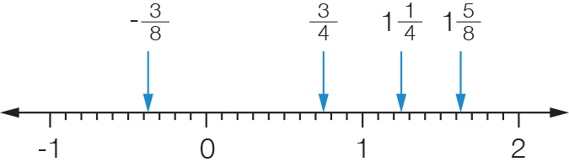

(b)   


(c)  is located just to the left of 1 on the number line, between  and 1.  
The closest number is , less than  away.

(d)  is smallest as it is the only negative number, then comes .  
 = and  =, so is next then because .  
 is the largest.  
Order is: –, , , , 

(e)  and  so there are 7 whole numbers in between (2, 3, 4, 5, 6, 7 and 8).

Question 21 9 marks [3.4, 3.5, 3.6]

|  |  |  |
| --- | --- | --- |
| (a) 1 +   = 1 +   = 1+  = 2 | (b) 2× 8 | (c) 8 ÷  = 8 ÷  =  =  =  No, 1 packet (8 cups) of flour is only enough for  cakes. |

Extended answer total: 18

TOTAL test marks: 64